**CentOS7下离线安装CDH5.12.0**

**说明：在本地虚拟机环境中进行CDH5.12.0集群的搭建，在搭建之前请先在虚拟机上装好三台CentOS7，三台内存分别为8g,2g,2g**

**准备**

* JDK环境   
  版本：jdk-7u79-linux-x64.rpm   
  下载地址：oracle官网
* mysql   
  tar包：[http://dev.mysql.com/get/Downloads/MySQL-5.6/Mysql-5.6.30-linux-glibc2.5-x86_64.tar.gz](http://dev.mysql.com/get/Downloads/MySQL-5.6/MySQL-5.6.26-1.linux_glibc2.5.x86_64.rpm-bundle.tar)   
  jdbc连接包mysql-connector-java.jar: <http://dev.mysql.com/downloads/connector/j/>
* CDH安装相关的包
  + cloudera manager包 ：5.12.0 cloudera-manager-centos7-cm5.12.0_x86_64.tar.gz   
    下载地址：[http://archive.cloudera.com/cm5/cm/5/cloudera-manager-centos7-cm5.12.0_x86_64.tar.gz](http://archive.cloudera.com/cm5/cm/5/cloudera-manager-centos7-cm5.7.2_x86_64.tar.gz)
  + CDH-5.12.0-1.cdh5.12.0.p0.29-el7.parcel
  + CDH-5.12.0-1.cdh5.12.0.p0.29-el7.parcel.sha1
  + manifest.json   
    以上三个下载地址在[http://archive.cloudera.com/cdh5/parcels/5.12.0/](http://archive.cloudera.com/cdh5/parcels/5.7.2/)，注意centos要下载el7的
* 虚拟机准备：相关安装略过，准备好三台环境一样的centos在本地虚拟机VMWare上，建议三台内存分别为8g,2g,2g，其中最大的那台可以当作主机，如果内存不够就设少点，三台虚拟机情况如下：

|  |  |  |  |  |  |  |  |  |  |  |  |  |  |  |
| --- | --- | --- | --- | --- | --- | --- | --- | --- | --- | --- | --- | --- | --- | --- |
| |  |  |  | | --- | --- | --- | | **IP地址** | **主机名** | **说明** | | 192.168.88.101 | master | 主节点master,datanode | | 192.168.88.102 | slave1 | datanode | | 192.168.88.103 | slave2 | datanode | |  |  |

**开始安装前配置和预装软件**

* 安装jdk（每台机器都要）   
  首先卸载原有的openJDK

[root@master~]$ java -version

java version "1.7.0_75"

OpenJDK Runtime Environment (rhel-2.5.4.2.el7_0-x86_64 u75-b13)

OpenJDK 64-Bit Server VM (build 24.75-b04, mixed mode)

[root@master~]$ rpm -qa | grep jdk

java-1.7.0-openjdk-1.7.0.75-2.5.4.2.el7_0.x86_64

java-1.7.0-openjdk-headless-1.7.0.75-2.5.4.2.el7_0.x86_64

[root@master~]# yum -y remove java-1.7.0-openjdk-1.7.0.75-2.5.4.2.el7_0.x86_64

[root@master~]# yum -y remove java-1.7.0-openjdk-headless-1.7.0.75-2.5.4.2.el7_0.x86_64

[root@master~]# java -version

bash: /usr/bin/java: No such file or directory

[root@master~]# rpm -ivh jdk-7u79-linux-x64.rpm

[root@master~]# java -version

java version "1.8.0_101"

Java(TM) SE Runtime Environment (build 1.8.0_101-b13)

Java HotSpot(TM) 64-Bit Server VM (build 25.101-b13, mixed mode)

* 修改每台节点服务器的有关配置hostname、selinux关闭，防火墙关闭   
  hostname修改：分别对三台都进行更改，并且注意每台名称和ip，每台都要配上hosts

[root@master~]# vi /etc/sysconfig/network

NETWORKING=yes

HOSTNAME=master

[root@master~]# vi /etc/hosts

192.168.88.101 master

192.168.88.102 slave1

192.168.88.103 slave2

selinux关闭(所有节点官方文档要求)

[root@master~]# vim /etc/sysconfig/selinux

SELINUX=disabled

重启才能生效

重启后检查

[root@master~]#sestatus -v

SELinux status: disabled

表示已经关闭了

关闭防火墙(注意centos 6 防火墙好像是iptables)

[root@master~]# systemctl stop firewalld

[root@master~]# systemctl disable firewalld

rm '/etc/systemd/system/dbus-org.fedoraproject.FirewallD1.service'

rm '/etc/systemd/system/basic.target.wants/firewalld.service'

[root@master~]# systemctl status firewalld

firewalld.service - firewalld - dynamic firewall daemon

Loaded: loaded (/usr/lib/systemd/system/firewalld.service; disabled)

Active: inactive (dead)

NTP服务器设置(用于不同节点间实现时间同步)

NTP服务的安装和配置

[root@master~]#yum -y install ntp

更改master的节点

[root@master~]## vi /etc/ntp.conf

注释掉所有server *.*.*的指向，新添加一条可连接的ntp服务器(百度一下ntp服务器，我选的是上海交大的)

server ntp.sjtu.edu.cn iburst

在其他节点上把ntp指向master服务器地址即可(/etc/ntp.conf下)

server 192.168.88.101 iburst

所有节点

* SSH无密码登录配置   
  安装过程中master需要各个节点的root免登录密码   
  先在master上生成公钥

[root@master]# ssh-keygen -t rsa

Generating public/private rsa key pair.

Enter file in which to save the key (/root/.ssh/id_rsa): [enter]

Created directory '/root/.ssh'.

Enter passphrase (empty for no passphrase): [enter]

Enter same passphrase again: [enter]

Your identification has been saved in /root/.ssh/id_rsa.

Your public key has been saved in /root/.ssh/id_rsa.pub.

The key fingerprint is:

1d:b1:99:51:31:d8:f6:6c:b1:84:f9:af:7b:2c:72:dd root@master

The key's randomart image is:

+--[ RSA 2048]----+

| o+++ |

| .*=.o |

| =. = o |

| . . * |

| S . . . |

| .|

| +.|

| . + E|

| o.+ |

+-----------------+

[root@master]# ssh-copy-id 192.168.88.102

The authenticity of host '192.168.88.102 (192.168.88.102)' can't be established.

ECDSA key fingerprint is e6:81:3f:9e:e6:bb:43:36:c7:4e:0f:6f:63:b2:12:a0.

Are you sure you want to continue connecting (yes/no)? yes

/usr/bin/ssh-copy-id: INFO: attempting to log in with the new key(s), to filter out any that are already installed

/usr/bin/ssh-copy-id: INFO: 1 key(s) remain to be installed -- if you are prompted now it is to install the new keys

root@192.168.88.102's password:

Number of key(s) added: 1

Now try logging into the machine, with: "ssh '192.168.88.102'"

and check to make sure that only the key(s) you wanted were added.

分别对两台节点进行以上操作，操作完了可以通过ssh ip进行验证是否可以无需输入密码就能直接登录到节点服务器上去

* 安装mysql   
  centos7自带的是mariadb，需要先卸载掉

[root@master]# rpm -qa | grep mariadb

mariadb-libs-5.5.41-2.el7_0.x86_64

[root@master huxin]# rpm -e --nodeps mariadb-libs-5.5.41-2.el7_0.x86_64

将下载好的[**MySQL**](http://lib.csdn.net/base/mysql) rpm包拷贝到服务器上然后解压

[root@master]# tar -xvf MySQL-5.6.24-1.linux_glibc2.5.x86_64.rpm-bundle.tar

然后安装释出的全部rpm:rpm -ivh [**mysql**](http://lib.csdn.net/base/mysql)-*.rpm   
修改配置文件路径：cp /usr/share/mysql/my-default.cnf /etc/my.cnf   
在配置文件中增加以下配置并保存

[root@master]#vim /etc/my.cnf

[mysqld]

default-storage-engine = innodb

innodb_file_per_table

collation-server = utf8_general_ci

init-connect = 'SET NAMES utf8'

character-set-server = utf8

以上就是安装好了。然后就初始化mysql   
然后初始化[**数据库**](http://lib.csdn.net/base/mysql)执行

[root@master]#/usr/bin/mysql_install_db

注意这个时候我遇到以下问题：

"FATAL ERROR: please install the following Perl modules before executing /usr/local/mysql/scripts/mysql_install_db:

Data::Dumper "

经过查询需要安装perl-Module

[root@master ~]# yum install -y perl-Module-Install.noarch

等待安装完了然后就可以执行上面的初始化语句了

- 启动mysql

[root@master]# service mysql restart

ERROR! MySQL server PID file could not be found!

Starting MySQL... SUCCESS!

- 查看mysql root初始化密码

[root@master]# cat /root/.mysql_secret

# The random password set for the root user at Fri Sep 16 11:13:25 2016 (local time): 9mp7uYFmgt6drdq3

- 登录进行去更改密码

[root@master]# mysql -u root -p

mysql> SET PASSWORD=PASSWORD('123456');

- 允许mysql远程访问

mysql> update user set host='%' where user='root' and host='localhost';

Query OK, 1 row affected (0.05 sec)

Rows matched: 1 Changed: 1 Warnings: 0

mysql> flush privileges;

Query OK, 0 rows affected (0.00 sec)

- 配置开机启动

[root@master]# chkconfig mysql on

拷贝mysql-connector-[**Java**](http://lib.csdn.net/base/java)到各个节点指定目录下(所有的节点)

[root@master]# cp mysql-connector-java-5.1.36-bin.jar /usr/share/java/mysql-connector-java.jar

创建数据库

create database hive DEFAULT CHARSET utf8 COLLATE utf8_general_ci;

Query OK, 1 row affected (0.00 sec)

create database amon DEFAULT CHARSET utf8 COLLATE utf8_general_ci;

Query OK, 1 row affected (0.00 sec)

create database hue DEFAULT CHARSET utf8 COLLATE utf8_general_ci;

Query OK, 1 row affected (0.00 sec)

create database monitor DEFAULT CHARSET utf8 COLLATE utf8_general_ci;

Query OK, 1 row affected (0.00 sec)

create database oozie DEFAULT CHARSET utf8 COLLATE utf8_general_ci;

Query OK, 1 row affected (0.00 sec)

grant all on *.* to root@"%" Identified by "123456";

**安装Cloudera-Manager**

* 解压cm tar包到指定目录所有服务器都要(或者在主节点解压好，然后通过scp到各个节点同一目录下)

[root@master ~]#mkdir /opt/cloudera-manager

[root@master ~]# tar -axvf cloudera-manager-centos7-cm5.12.0_x86_64.tar.gz -C /opt/cloudera-manager

* 创建cloudera-scm用户（所有节点）

[root@master ~]# useradd --system --home=/opt/cloudera-manager/cm-5.12.0/run/cloudera-scm-server

--no-create-home --shell=/bin/false --comment "Cloudera SCM User" cloudera-scm

* 在主节点创建cloudera-manager-server的本地元数据保存目录

[root@master ~]# mkdir /var/cloudera-scm-server

[root@master ~]# chown cloudera-scm:cloudera-scm /var/cloudera-scm-server

[root@master ~]# chown cloudera-scm:cloudera-scm /opt/cloudera-manager

* 配置从节点cloudera-manger-agent指向主节点服务器

vim /opt/cloudera-manager/cm-5.12.0/etc/cloudera-scm-agent/config.ini

将server_host改为CMS所在的主机名即master

* 主节点中创建parcel-repo仓库目录

[root@master ~]# mkdir -p /opt/cloudera/parcel-repo

[root@master ~]# chown cloudera-scm:cloudera-scm /opt/cloudera/parcel-repo

[root@master ~]# cp CDH-5.12.0-1.cdh5.12.0.p0.18-el7.parcel CDH-5.12.0-1.cdh5.12.0.p0.18-el7.parcel.sha manifest.json /opt/cloudera/parcel-repo

注意：其中CDH-5.12.0-1.cdh5.12.0.p0.18-el5.parcel.sha1 后缀要把1去掉

* 所有节点创建parcels目录

[root@master ~]# mkdir -p /opt/cloudera/parcels

[root@master ~]# chown cloudera-scm:cloudera-scm /opt/cloudera/parcels

解释：Clouder-Manager将CDHs从主节点的/opt/cloudera/parcel-repo目录中抽取出来，分发解压激活到各个节点的/opt/cloudera/parcels目录中】

* 初始脚本配置数据库scm_prepare_database.sh(在主节点上)

[root@master ~]# /opt/cloudera-manager/cm-5.12.0/share/cmf/schema/scm_prepare_database.sh mysql -hmaster -uroot -p123456 --scm-host master scmdbn scmdbu scmdbp

说明：这个脚本就是用来创建和配置CMS需要的数据库的脚本。各参数是指：

mysql：数据库用的是mysql，如果安装过程中用的oracle，那么该参数就应该改为oracle。

-hmaster：数据库建立在master主机上面。也就是主节点上面。

-uroot：root身份运行mysql。-123456：mysql的root密码是***。

--scm-host master：CMS的主机，一般是和mysql安装的主机是在同一个主机上。

最后三个参数是：数据库名，数据库用户名，数据库密码。

注意:如果执行的时候报一下错误,可能是配置host的有问题，127.0.0.1 localhost.master 这个localhost不能少

ERROR com.cloudera.enterprise.dbutil.DbProvisioner - Exception when creating/dropping database with user 'root' and jdbc url 'jdbc:mysql://localhost/?useUnicode=true&characterEncoding=UTF-8'

java.sql.SQLException: Access denied for user 'root'@'localhost' (using password: YES)

这里我也遇到以下另一个问题

ERROR com.cloudera.enterprise.dbutil.DbProvisioner - Exception when creating/dropping database with user 'root' and jdbc url 'jdbc:mysql://localhost/?useUnicode=true&characterEncoding=UTF-8'

java.sql.SQLException: Your password has expired. To log in you must change it using a client that supports expired passwords.

这里可以重新设置mysql的数据，然后刷新，或者直接将过期设置不检测

mysql> update user set password_expired='N' where user='root';

Query OK, 2 rows affected (0.00 sec)

Rows matched: 5 Changed: 2 Warnings: 0

mysql> flush privileges;

* 启动主节点cloudera-scm-server

[root@master ~]# cp /opt/cloudera-manager/cm-5.12.0/etc/init.d/cloudera-scm-server /etc/init.d/cloudera-scm-server

[root@master ~]#chkconfig cloudera-scm-server on

此时service cloudera-scm-serverstart的话会报错：“File not found: /usr/sbin/cmf-server”，因为cloudera-scm-server里面的变量路径配置不正确！

[root@master ~]# vim /etc/init.d/cloudera-scm-server

CMF_DEFAULTS=${CMF_DEFAULTS:-/etc/default}改为=/opt/cloudera-manager/cm-5.12.0/etc/default

此时service cloudera-scm-server start就不会报错了

同时为了保证在每次服务器重启的时候都能启动cloudera-scm-server，应该在开机启动脚本/etc/rc.local中加入命令：service cloudera-scm-server restart

* 启动cloudera-scm-agent所有节点

[root@hadoopX ~]# mkdir /opt/cloudera-manager/cm-5.12.0/run/cloudera-scm-agent

[root@hadoopX ~]# cp /opt/cloudera-manager/cm-5.12.0/etc/init.d/cloudera-scm-agent /etc/init.d/cloudera-scm-agent

[root@hadoopX ~]# chkconfig cloudera-scm-agent on

同样此时service cloudera-scm-agent start的话会报错：File not found: /usr/sbin/cmf-agent，因为cloudera-scm-agent里面的变量路径配置不正确！参照cms的配置

同时为了保证在每次服务器重启的时候都能启动cloudera-scm-agent，应该在开机启动脚本/etc/rc.local中加入命令：service cloudera-scm-agent restart

**在浏览器安装CDHs**

等待主节点安装并且启动就在浏览器中进行操作了   
进入192.168.88.101:7180 默认使用admin admin登录   
以下在浏览器中使用操作安装

选择express版本   
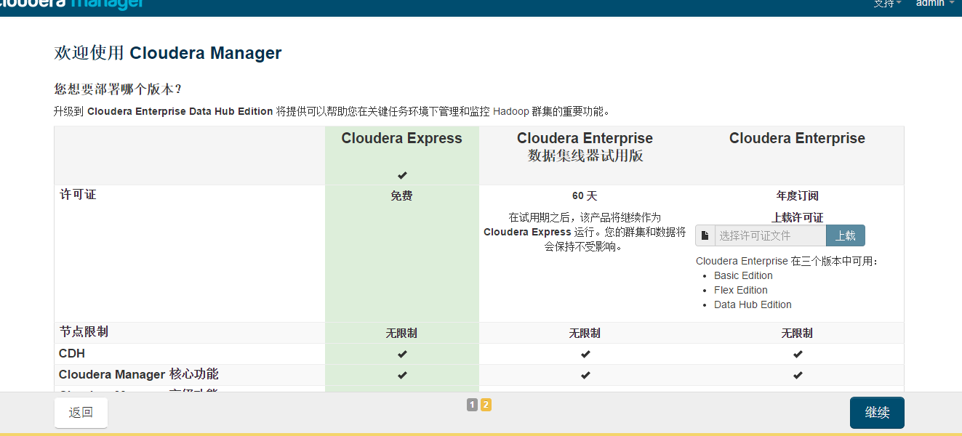

组件提示   
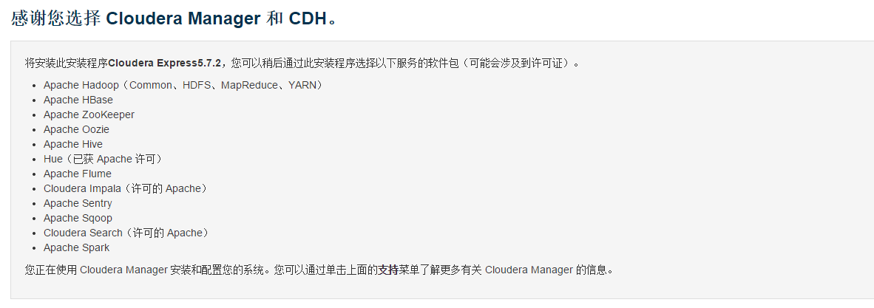  
配置主机!由于我们在各个节点都安装启动了agent，并且在中各个节点都在配置文件中指向master是server节点，所以各个节点的agent就会给agent发消息报告，所以这里我们可以在“当前管理的主机”中看到三个主机，全部勾选并继续，注意如果cloudera-scm-agent没有设为开机启动，如果以上有重启这里可能会检测不到其他服务器。   
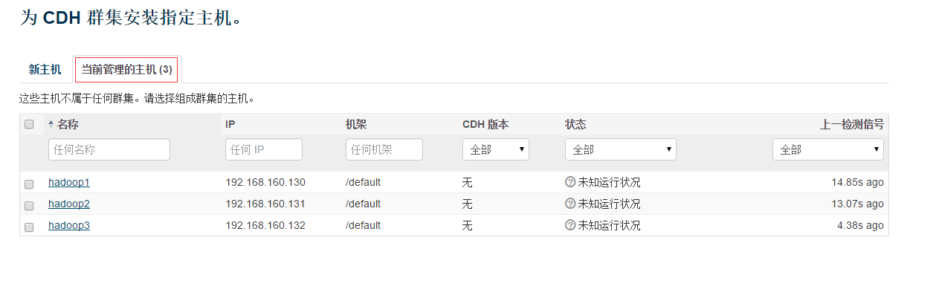

选择cdh   
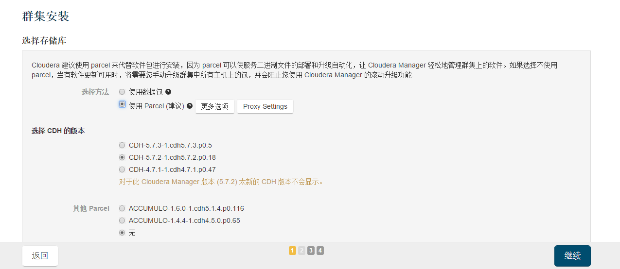

分发parcels到各个节点   
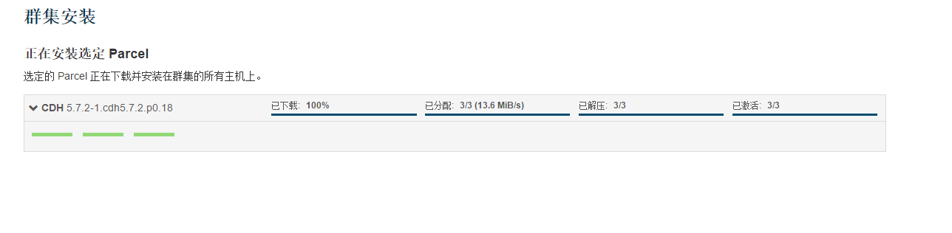

之间正确性的检测   
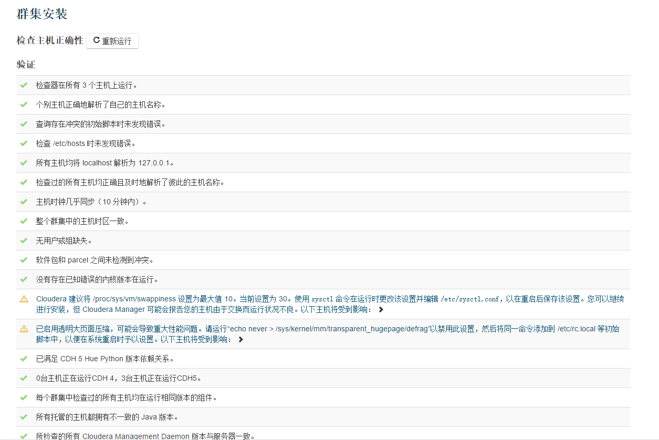  
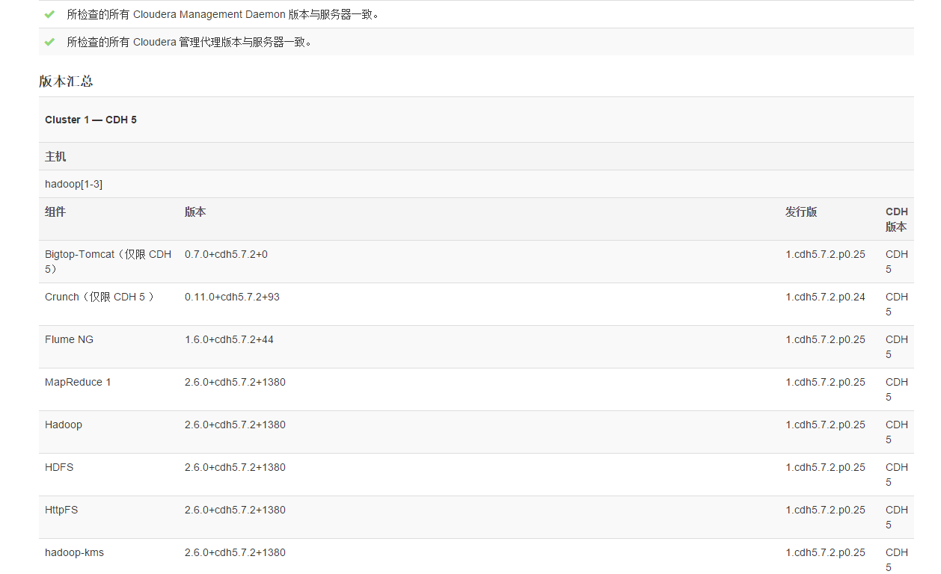  
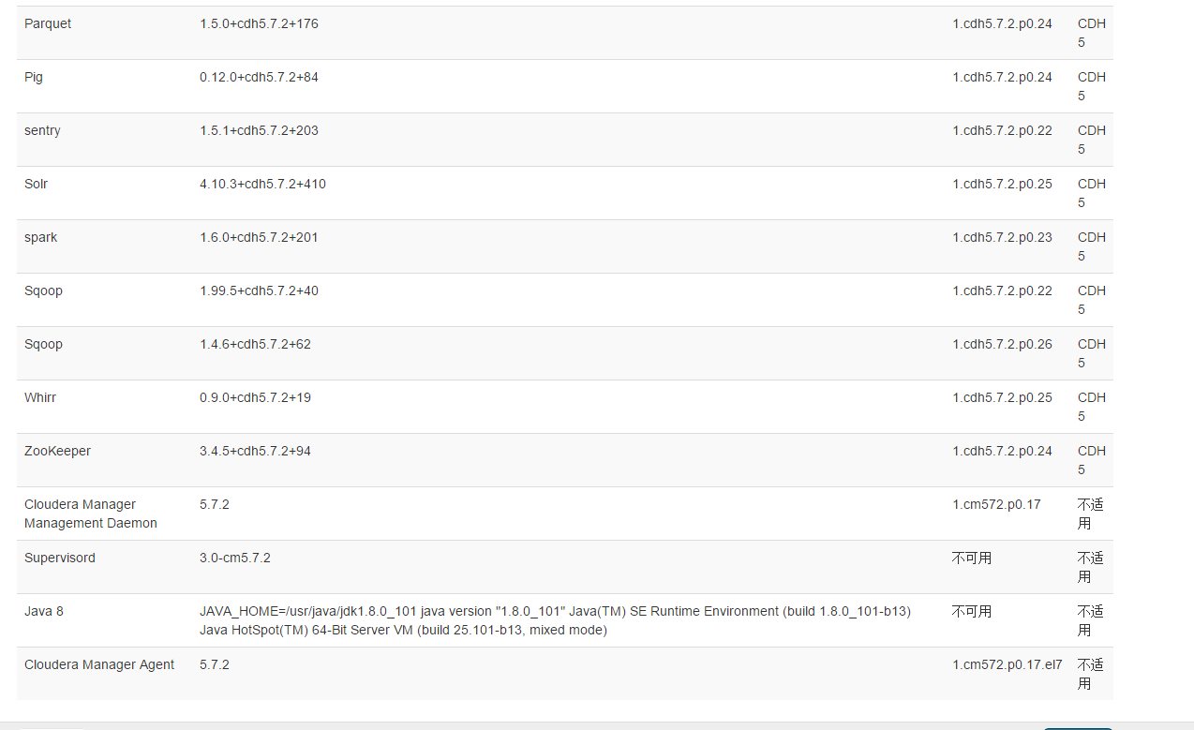

选择要安装的服务，这里选择所有服务   
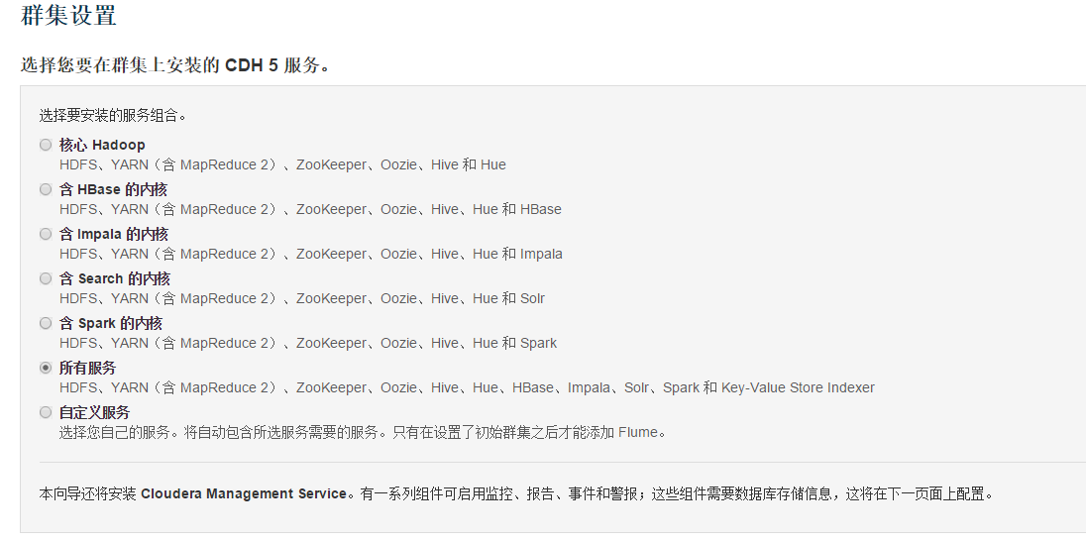

角色分配   
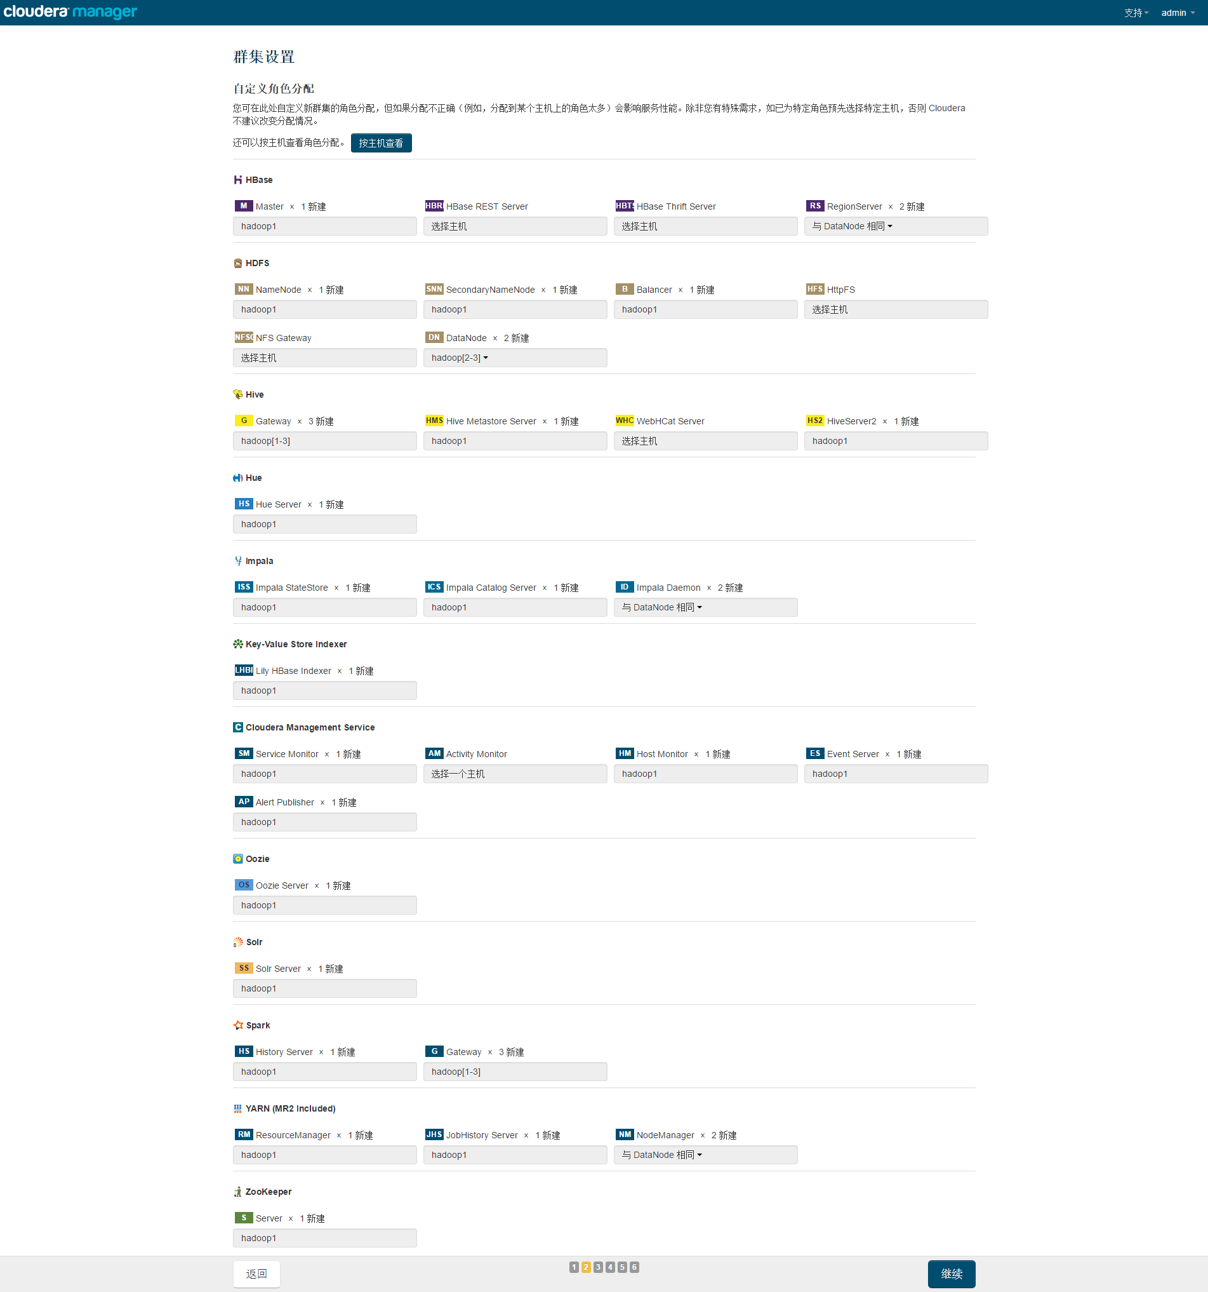

数据库设置选择   
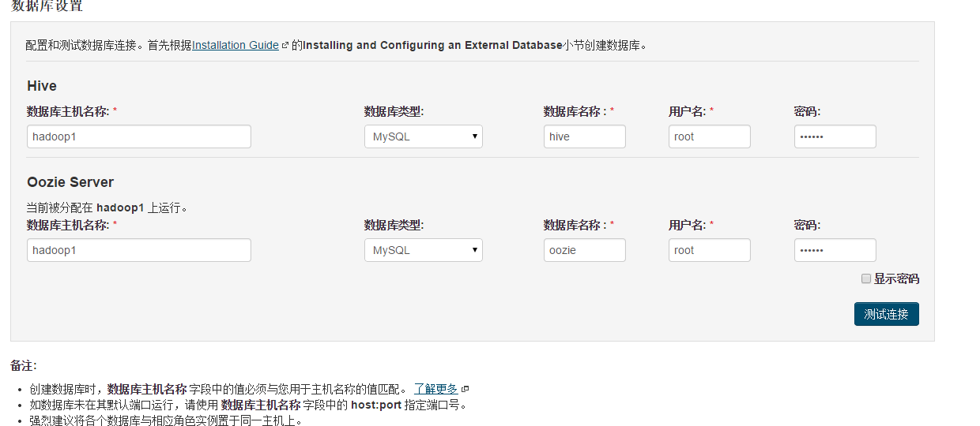

集群审核，这里都默认的   
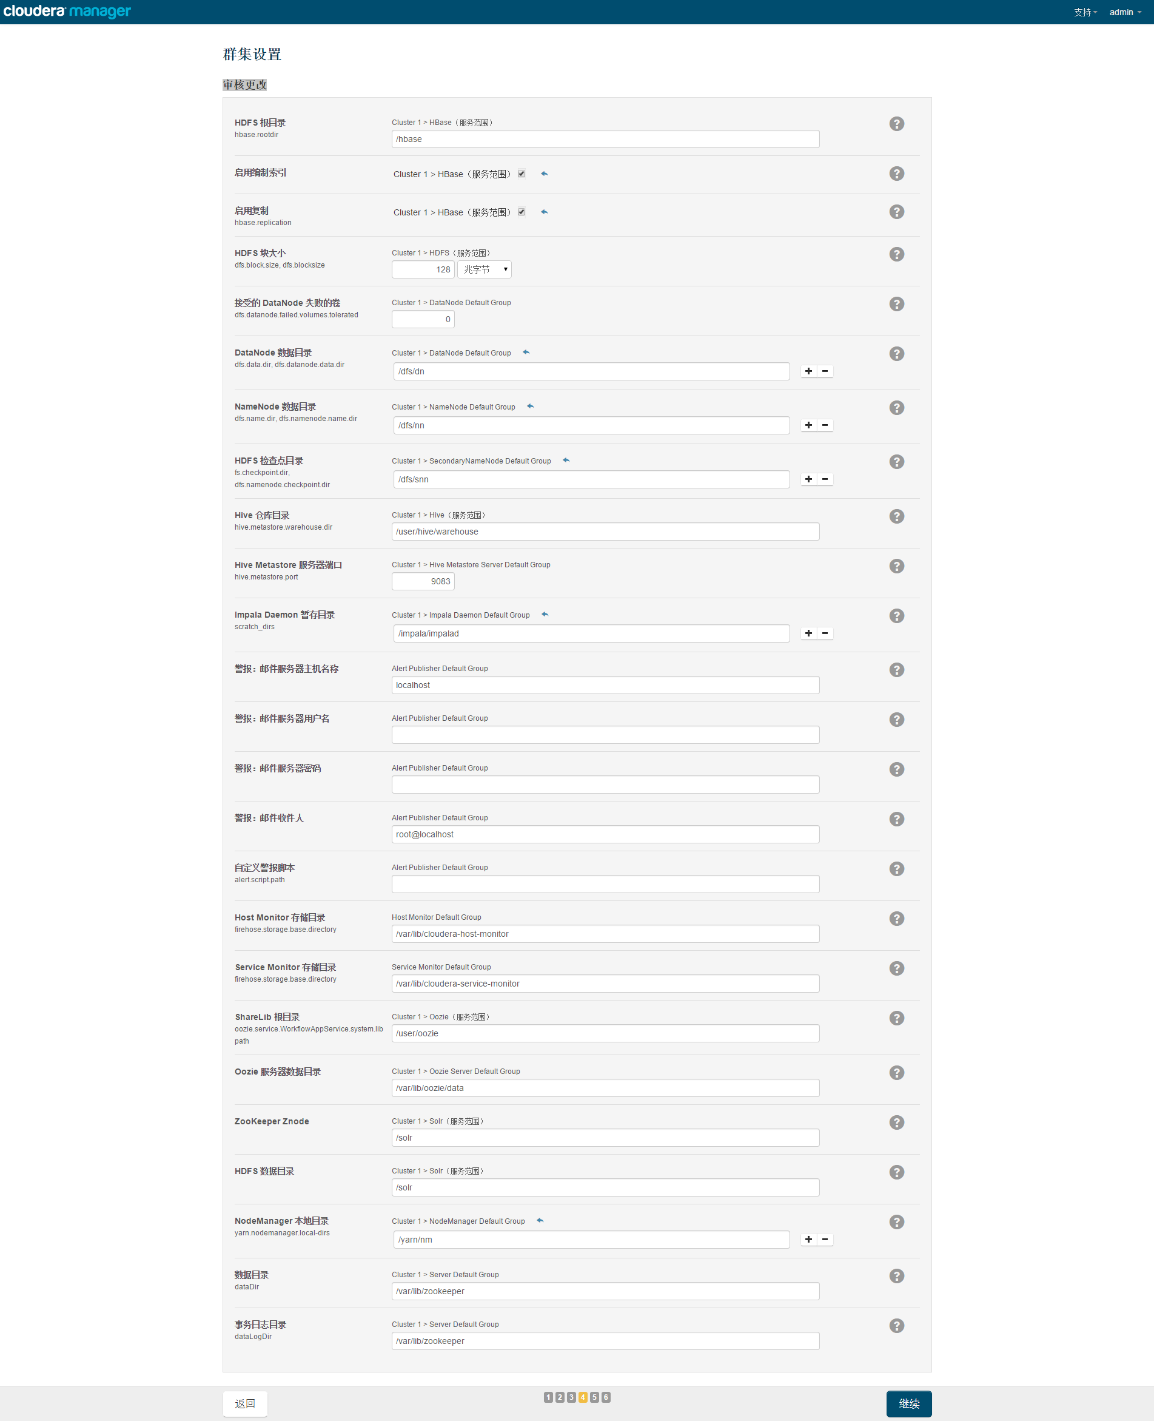

开始安装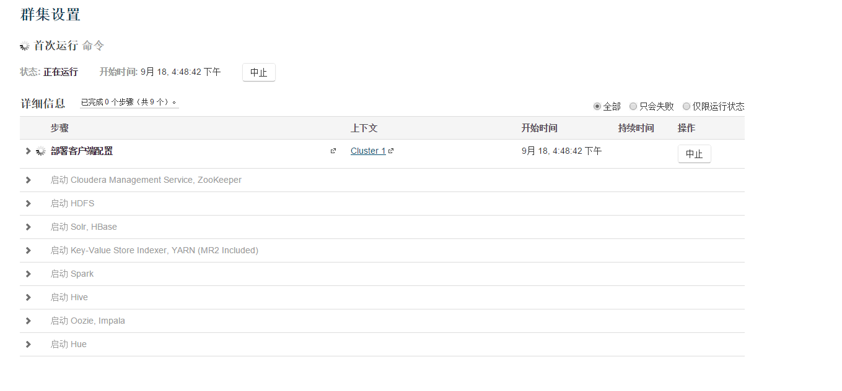

安装完成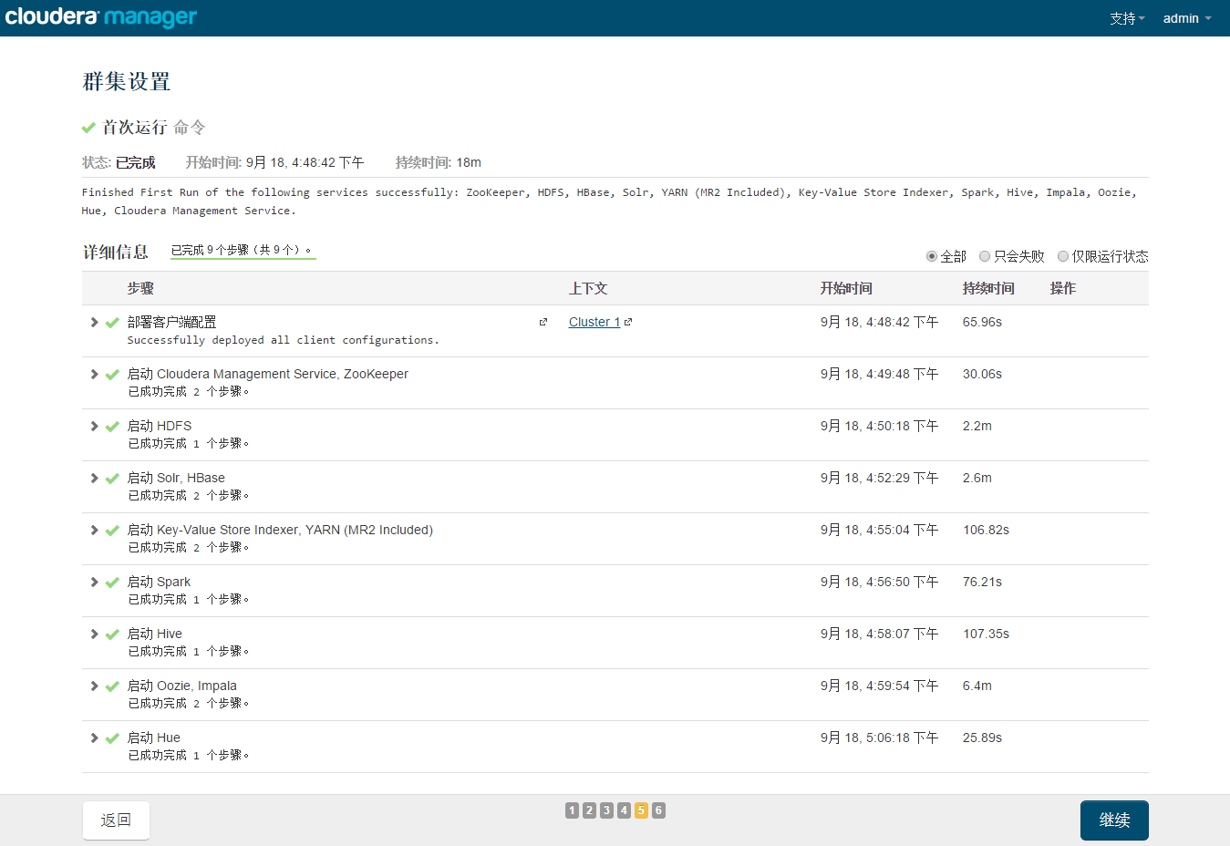   
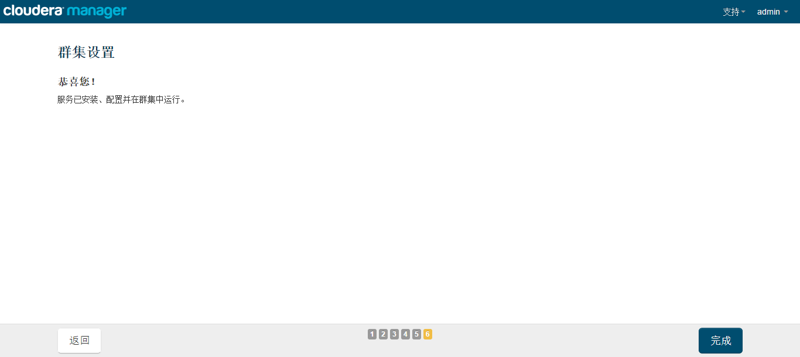

这个时候安装完成了，可以在浏览器中进入192.168.88.101:7180地址，查看集群情况，我这里有挺多报警，大概查看下基本都是内存或者存储空间使用阈值的报警，由于我们是本地虚拟机的，所以这些条件都有限，这里暂时不care这些报警了   
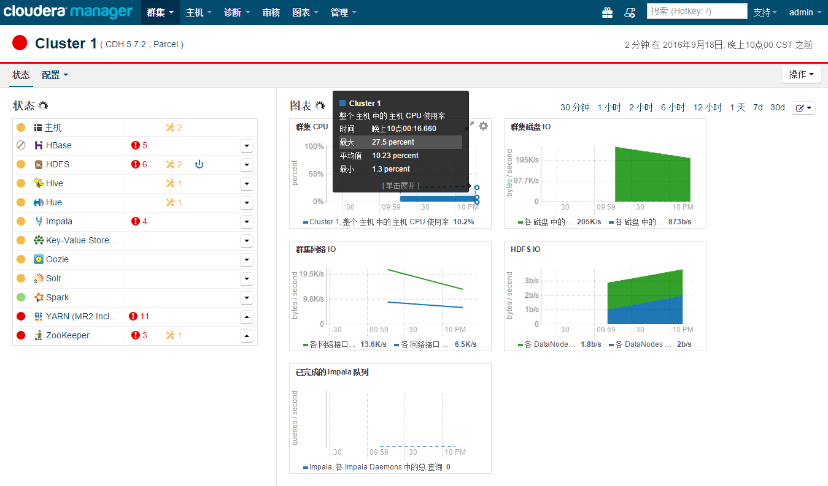  
安装完成！！！